**BE YOUR OWN TRAINER**

**Home fitness Guide Book**

# Copyright © 2020

# All Rights Reserved

*All rights to this book are reserved. No permission is given for any part of this book to be reproduced, transmitted in any form or means; electronic or mechanical, stored in a retrieval system, photocopied, recorded, scanned, or otherwise. Any of these actions requires the proper written permission of the author.*

**YOUR FITNESS JOURNEY**

LEARN HOW TO WORKOUT 7

CHAPTER 1: PULL-UPS 10

CHAPTER 2: PLANKS 22

CHAPTER 3: PUSH-UPS 32

CHAPTER 4: LUNGES 45

CHAPTER 5: SQUATS 55

CHAPTER 6: ABS TRAINING 63

CHAPTER 7: BRIDGE EXERCISE 73

START WORKOUT NOW 82

# Disclaimer

*All knowledge contained in this book is given for informational and educational purposes only. The author is not in any way accountable for any results or outcomes that emanate from using this material. Constructive attempts have been made to provide information that is both accurate and effective, but the author is not bound for the accuracy or use/misuse of this information.*

# LEARN HOW TO WORKOUT

You are fit when your body is healthy and physically strong. A survey conducted some years ago, in 2014 suggests that nearly 30 percent of the global population are either overweight or obese. The statistics have not proved to be getting better. This simply tells you that a lot of people are going through life without being fit. Perhaps you fall into this category, or you simply feel the need to get in shape but you have not started a fitness regimen. You might be too busy, or a gym membership might be too expensive where you stay. Being fit is not just about having a great summer body (although that would be a welcome plus). Being healthy comes as a result of observing a workout plan, be it at the gym or in the comfort of your bedroom.

It is the outcome of developing healthy habits like eating a balanced diet and regular exercising. Working out in your personal space is undoubtedly more convenient for you. You don’t have to deal with complicated equipment or endure staring eyes.

You may think you need a personal trainer, while that would be good. What is significant is that you have the opportunity to do it all on your own.

This is the part where this book comes to play. I came up with simple workout plans you can do in the comfort of your home

You should pursue a fitness plan because it is vital to stay healthy. Forming healthy habits will have a high impact on you as you grow older. Your body is designed to recover and adapt to new habits if you would take some minutes out of your day to get in shape. You deserve to be the healthiest version of yourself, not only will you look better, you will indeed be better and more youthful.

You don’t have to go crazy on crash diets or place a substantial restriction on your favorite meals. I will tell you just how to go about creating a fitness regimen and a healthy body.

Perhaps you want to begin your fitness journey, or you are already-fit and are looking for more ways to incorporate fitness into your schedule. Whatever bracket you fit into, it is always a good idea to exercise at home.

The three general types of exercises, upper-body exercises, lower-body exercises, and abdominal exercises, can all be performed to develop your body at home without expensive equipment. The combination of activities you should focus on will be dependent on your physical state and the outcome you want to achieve.

Luckily, you can do these exercises freehand in your home without any real help from anyone.

Chapter 1

# PULL-UPS

The pull up is an extremely effective way to strengthen the muscles of your back. The most massive back muscle, called the Latissimus dorsi, runs from the middle of your back to your under armpits and across your shoulder blades.

The back of your neck has a muscle that travels from there to your left and right shoulders. Your thoracic spine, a critical segment of your return, constitutes three muscles. All these muscles are held up and contracted and relaxed when you perform pull-ups.

This process develops and strengthens the muscles of your back. If you do it regularly, you will also improve the muscles of your shoulder and your arms. Once your muscles are stronger, your grip would be stronger and thus become firmer. Pull-ups are a resistance training exercise that will increase your fitness level in general.

When you do a pullup, you elevate your entire body in that upward movement, and the upwards and downwards movement will develop your body’s stamina.

It also makes your heartbeat go faster than when your body is in a resting position. This trains your heart and results in an enhancement of your cardiovascular health.

Asides improving your fitness level, and the strength of your heart, studies have shown that doing pull-ups regularly helps in the reduction of visceral fat, which will lead to an overall improvement of your physical health which means that you have an improved posture, a strengthened core, and a whole, healthy body if you can just keep it the performance up.

A pull-up is a training exercise intended to strengthen your upper body. Your upper body includes your arms, your shoulders, your back, your abdominals, and your chest. It is probably the only exercise you can do to build muscular biceps without gym equipment.

However, in doing pull-ups, make sure you have the right gear to move around in. You do not have to break the bank to achieve this.

Get any breathable shirt that you own.

Look out especially for a fabric that would absorb your sweat as you expend energy. The most important thing is that it is comfortable for you.

You may need to spend some extra money here by investing in good shoes to give your feet the support it needs to exercise without getting yourself hurt.

For a woman, you should have a firm sports bra that can support you while doing high-intensity workouts once you are all decked out, you ready to start working out.

To do a pull up at home, find any strong bar suspended in the air by being attached firmly to a wall. Some doors have bars at the top with which you can do the pullup.

Then, face your palms away or towards you. Place your hands on the bar and latch on firmly.

Then you stretch your body straight up so that your entire body is fully extended.

The pullup has many variations that, when performed, will only further strengthen you. By combining pullups with the other exercises in this book, you will create a fitness routine.

***Different Levels of Pull-ups Exercise***

There are variations of performance when it comes to performing pullups. They can range from beginner moves to more advanced ones. The advanced ones are more difficult.

Frankly, pullups are not easy to learn, but an important lesson to learn in your quest for fitness is the art of endurance. Persevering will take you very far.

For a beginner, you can first master the easier one which is the classic pullup before you proceeding to perform more advanced levels or variations of the pullup.

* BeginnerLevel

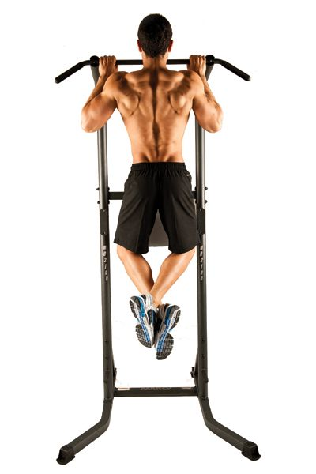**Classic pullup**

1. Take a leap and grasp the bar with your hands placed shoulder width apart.
2. Face your palms away from you and ensure that your arms are fully extended.
3. If your feet ate still touching the ground, you can bend your knees.
4. Engage the muscles of your shoulders, back and core
5. Pull up by working your upper-body muscles
6. Inch your body upwards until your chin clears the bar
7. Move slowly and steadily downwards till your arms are fully extended once more.

Attempt ten repetitions of the exercise, but don't be discouraged if you don’t meet that target.

**Negative pullups**

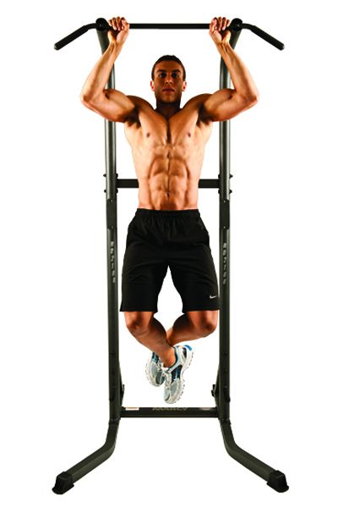This exercise is easier than the classic pullup as it eliminates the tough process of moving your body upwards.

*Follow these steps to perform the negative pull up.*

1. Stand on a bench.
2. Grasp the bar with your palms facing away from you.
3. Make sure that your chin is just above the bar
4. Lower yourself as slowly as possible.

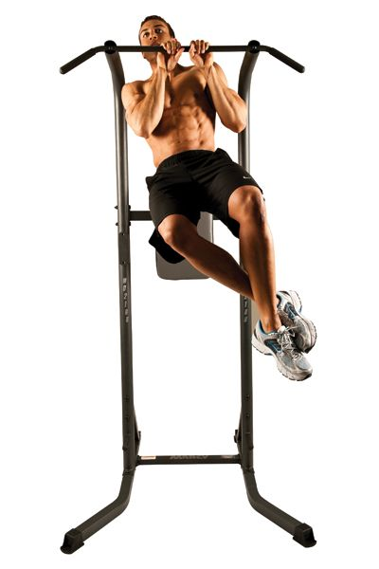**Kipping Pullup**

This move builds power in all your major back muscles. Follow these steps to perform the skipping pullup.

1. Take a leap and grasp the bar with your hands placed shoulder width apart.
2. Face your palms away from you and ensure that your arms are fully extended.
3. Gently swing your legs
4. Engage the muscles of your shoulders, back and core
5. Pull up by working your upper-body muscles
6. Inch your body upwards until your chin clears the bar
7. Move slowly and steadily downwards till your arms are fully extended once more.

Attempt ten repetitions of the exercise,

* Advanced levels

**Tarzan Pullup**

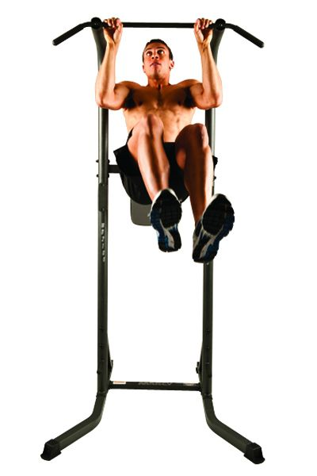This move requires more coordination when you raise your body. It engages your core muscles to prevent your lower body from swinging.

Follow these steps to achieve the Tarzan pullup.

1. Grasp the bar with your hands almost touching.
2. Face your palms away from you and ensure that your arms are fully extended.
3. Engage the muscles of your shoulders, back and core
4. Pull up by working your upper-body muscles
5. Inch your body upwards until your chin clears the bar
6. Twist your body to the right
7. Move slowly and steadily downwards till your arms are fully extended once more.
8. Repeat the pullup, but this time as you go up, twist to the left.

Attempt ten repetitions of the exercise.

**Simple Pullups Plan To Follow**

The number of repetitions (reps) you do each set is dependent on two things:

* Maximum of reps
* The number of games you’re planning on doing throughout the day.

With that, you can do ten pull-ups a day. That is ten ups and ten downs.

Do the following three times in a week to get the desired result.

Ensure you take at least 5 minutes to break in while on five pull-ups for the first day.

Reduce the breaks as you advance until you can do ten pull-ups at a go.

Use gloves to protect your hands.

Chapter 2

# PLANKS

If you are on a quest to getting a flat stomach and six-pack abs with your fitness activities at home, then the plank is one of the best and most excellent abdominal and core exercises you should consider for a healthy and flat stomach. You might have been more focused on doing crunches during your cardiovascular workout.

But the truth is that though crunches may be the most common form of abdominal exercise, they may not be the most effective for building muscle and strengthening your core. An entire hour of doing crunches does not even give half of the body benefits that a 10-minute plank workout exercise will provide you with.

Planks are great additions to any exercise routine as they are equipment-free and easy to perform. The exercise requires your arms, your legs, and all of your abs which makes it an all-encompassing workout and a more efficient way to exercise. Planks can also be modified to suit your body needs. It can be changed by adding varieties or increasing the length of time you can hold the pose.

The plank is regarded as the best exercise for a strong stomach, for it offers so many benefits.

***Plank build your core muscles****.* Planks do not work only on the rectus abdominis, but also on the other ab muscles- six-packs muscles, and even the muscles in your core that run from the pelvis along the spine and up to the shoulder girdle. It also works on your deepest abs muscles-transverse abdominus, your internal and external obliques on your body sides, your hips, and back.

***Planks help to strengthen and improve your body posture****.* If you have been experiencing body pains from sitting in class or at your all day long, here is an excellent way to strengthen your muscles and improve your posture!

Planks help you to strengthen your core body muscles, which serve as the basis for any of your coordinated and powerful athletic movements. It is more of a strength-building exercise than a cardio-vascular use.

By strengthening your muscles, this exercise provides support for your entire body during everyday movements, helps to reduce back pain, and to improves posture. It ensures that you can keep your shoulders and your lower back in a neutral position while you are sitting or standing. Planks help to stabilize, balance, and power the body during just about every other activity.

***Planks burn more calories****.* Plank exercises burn more calories than traditional crunches. This is because they recruit all muscles in the legs, arms, and rear during the training. It is an ultimate total-body exercise.

**Different Levels of the Plank Exercise**

Having known the benefits of doing plank exercises, the next thing for you to know is how to do planks. Before we start, you need to understand that getting into the plank position is relatively simple, but the real job lies in your ability to maintain that position for a while. There are different levels of doing the plank exercise, which reads from the easiest to the hardest.

**Side planks**

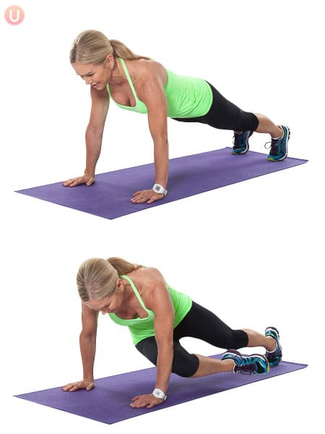Lay on your right side and prop yourself up onto your right forearm, which should be on the ground. The hands of your right foot should also be braced on the ground.

Engage your core and raise your hips, so your body forms a straight line from your feet to your head.

You can try stacking your left foot on top of your right foot or placing both feet on the ground. Hold this position for as long as you can. Repeat on your left side.

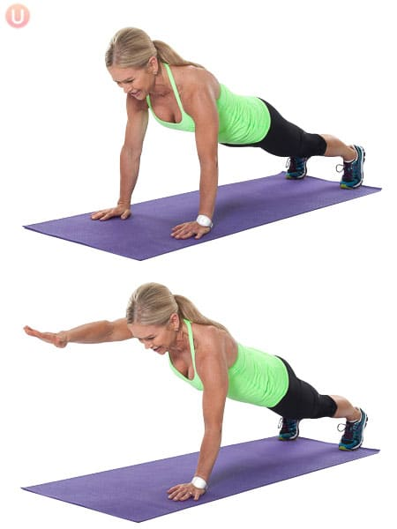**Plank With Arm Lift**

As you become more advanced with your planking skills, you can put yourself up for a challenge by adding variety to the basic plank-like an arm lift.

Start with the perfect plank position as above.

Carefully shift your weight to your right forearm. Take your left arm off the ground and extend it straight out in front of you.

Use your right arm and toes to hold and balance your body for three seconds while keeping your core tight.

Slowly bring your arm back to the starting position and repeat the action on your opposite side. Do ten taps on each side to start, but increase your number as your balance improves.

The movement may be tricky to master at first, but it will engage your entire core while also improving your balance.

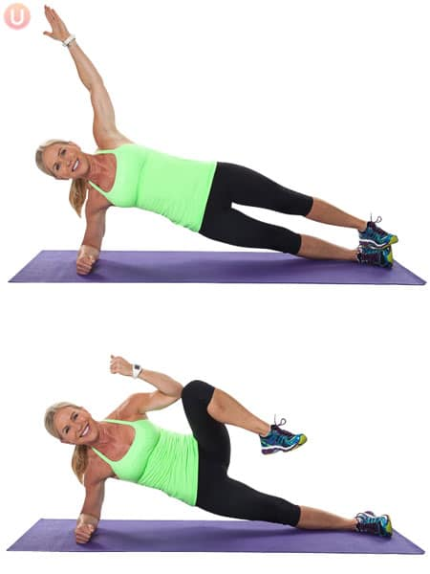**Knee to elbow Plank**

Start in the regular plank position with your hands shoulder-width apart on the floor

Engage your ab muscles and keep your back straight

Slowly lift your right foot 5 to 8" off the ground and towards your right elbow. Count to ten and return the right foot to the full plank position.

Switch legs and repeat the same action on your left side, moving your left foot towards your left elbow.

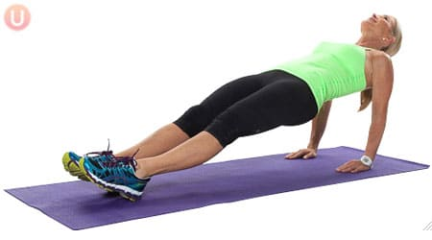**Reverse Plank**

Start seated on the floor with legs long in front of your body. Then place hands behind your hips.

Make the space between them slightly wider than your shoulders with your fingers pointed towards your hips.

Lift your hips and torso off the floor and gaze up towards the ceiling keeping your neck relaxed.

Keep your body in a long line with softly pointed toes. Hold for 30 seconds, then release to the floor slowly.

**Simple Plank Workout Plan to Follow**

As a beginner, you can start with the first three plank exercises. Ensure to hold each plank pose for 10 to 20 seconds. Repeat the entire series three times in total.

When you become well versed with the first three planks, you can advance to incorporate the final two exercises, holding each one for 30-60 seconds.

For a killer core workout, combine all five poses into one routine. Start with a 20- to 30-seconds hold of all the poses and the. Increase your time from there. Make two minutes your maximum time limit.

If you want to increase your athletic performance, research has shown that repeated 10-second holds may be the best workout plan.

Chapter 3

# PUSH-UPS

Pushups are more comfortable to perform than pullups. It strengthens your upper body, just like the pullup. Pushups work your pectoral muscles in your chest as well as your triceps. Performing pushups is a more straightforward and equally effective way to enjoy almost the same benefits you would if you performed pull-ups instead.

When you do push-ups, your target muscles are your chest muscles, shoulder muscles, triceps, abdominals, and your serratus anterior, which are the muscles under your armpit.

There are many variations of pushups, and all of them will quickly help you to strengthen your body. These variations range from easy beginner levels to more advanced levels. The push-up is extraordinarily beneficial, and almost all the muscles of your body are worked to some degree. And the most fantastic thing about it is that you need little or no gear.

Your entire body weight is trained, and it would go a long way to make you fit since you are working out at home, and not at the gym with fancy equipment, it would be advisable for you to invest in a mat or a rug to place on the ground to cushion the friction of the floor against your body.

Let’s get to it.

Pushups are arguably the most well-known bodyweight exercise as It is the first freehand exercise. You would think that since it is so popular, people would know how to do it correctly, but as it is, a lot of people do push-ups in the wrong way.

You will be learning it from scratch regardless of how you have always known to do it. But being honest with yourself about your fitness will take you a long way in your fitness journey.

As was mentioned earlier, your whole body is trained when you do a push-up. Every muscle in your body is worked from your biceps to your core muscles down to your lower-body muscles. This puts the push-up in the class of compound exercises.

That simply means that multiple muscle groups are worked when performing the exercise. What this does to your body is that you become more visibly defined. This happens because utilizing those muscles in that manner causes the production and release of the Human Growth Hormone, HGH.

The pushup is a very effective way to improve your posture. Since your core muscles become strengthened when you do pushups consistently and adequately, it naturally improves your posture, as a leading cause of bad attitude is weak core muscles.

The muscle that is worked the most when you do the pushup is the entire pectoral muscle. When you first start doing this exercise, it may be hard for you to do several repetitions, but don’t focus too much on that. Focus on being consistent. The consistency will make your muscles stronger, and naturally, you will be able to do several repetitions.

What this exercise can also do for your body is that prevent against injuries. Just as a wet branch is harder to break; a healthy back is harder to break. If you train your body with this exercise, you develop your lower back muscles.

Injuries to your lower back muscles can be extremely enervating. Pushups will reduce the likelihood of getting injured in delicate areas by building muscles that reduce lower back pressure.

**Different Levels of Pushups**

The exercise can range from simple levels to more advanced levels. If you have been able to pull off several repetitions of Pushups, then you may be able to do advanced levels of a pushup, but if not, it is best to begin at the simple routines.

There are three types of Pushup

* The standard
* The diamond
* The wide-arm.

*Standard pushup*

For this, your hands should be positioned slightly wider than your shoulders. This way, you work your biceps and pectoral muscles.

*Diamond pushup*

This, you should place your hands firmly in the shape of a diamond. Then place them directly under your chest. To put more pressure on your pectoral muscle, do the wide-arm pushup.

*Wide-arm pushups*

Do this by positioning your hands much farther than shoulder-width apart before proceeding to do the pushup.

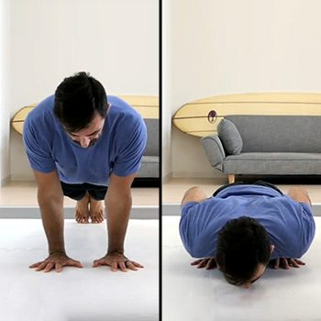**Easy pushups (standard)**

1. Lower your body to the floor face- down. Keep your feet together and channel your body
2. Place your hands approximately shoulder-width apart
3. Hold your body straight and exhale while pushing your body up until your arms are straight
4. Lower your body to the floor as you breathe in
5. Allow your chest to touch the floor
6. Hold your stomach, head, and knees from touching the floor
7. Do a full repetition (10 reps is good for starters)

**Advanced pushups**

Once you have got the hang of the standard pushup, you can do the same process, but with little twists along the way.

**Clap pushups**

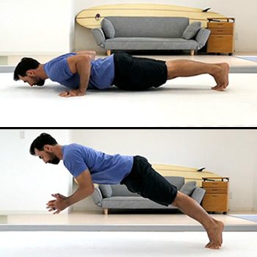This level of pushup is also called **plyometric pushup.** Follow the following steps to perform the clap pushup.

1. Lower your body to the floor face- down.
2. Keep your feet together and channel your body
3. Place your hands on the floor by a distance of shoulder-width
4. Hold your body straight, exhale and push your body up until your arms are straight.
5. Lower your body to the floor as you inhale, push your body off the ground with force
6. Put your palms together in a clap mid-air
7. Return your palms to their former position
8. Allow your chest to touch the floor
9. Hold your stomach, head, and knees from touching the floor
10. Do a set of 10 repetitions

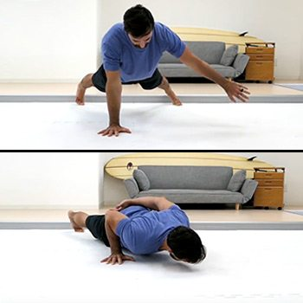**One-arm pushup**

This is another advanced level of the pushup. Here you do the exercise by utilising only one of your arms. This move strengthens your core muscles.

Follow these steps to perform it

1. Lower your body to the floor face- down.
2. Stretch your feet further apart than normal to maintain balance.
3. Place your one arm behind your back
4. Continue the pushup as you would do the standard (you can refer to it)

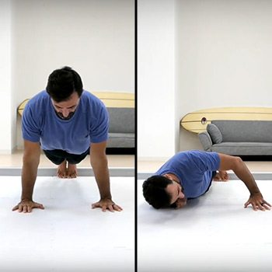**Screw up push ups**

The screw up targets your shoulders and elbow. It is by far one of the difficult levels of the push up exercise. However, with time you will get the hang of it.

Keep your elbow by your side.

Ensure you carry the rest of your body along and avoid allowing your torso sag.

Note: To avoid injuries while doing the Screw up exercise, ensure that your shoulders are mobile enough to take on the work out. Remember despite being determined to be fit, your overall health is paramount. Keep this in mind.

**Simple Push-ups Plan To Follow**

To fit these variations in, build a routine that incorporates three or four of the exercises at a time. Include them in your freehand bodyweight workouts as a finisher or dedicate a session to them.

*Example*

3 x 20 Plyometric pushups

3 x 10 Wide-arm pushups

3 x 10 standard pushups

3×10 one-arm pushups

Fitness involves good exercise and nutrition, so take more proteins to build muscle mass.

Chapter 4

# LUNGES

Lunges are a functional multi-joint exercise that can easily be modified to meet your fitness level at home. As a man or woman, if your principal aim is to shape your lower body or to make your hips more flexible during your home fitness activities, then the plunge can surely help you to achieve your goal.

The lunge is a simple one-trick fitness exercise than you can do it at home to build your foundational strength and for excellent calorie-burning in your body.

Generally, as an exercise activity, making lunges involves standing with your chest up, your eyes ahead, your right foot forward as well as the bending of your knees at about a 90-degree angle. However, these procedures differ from one lunges level to another.

Whether you are doing the basic beginner lunges or the advanced ones, this exercise is very beneficial in different ways.

***Give your booty a strong lift****.* Lunges are one of the best ways to give your booty a visible lift. This exercise does this effectively by challenging and working on your glutes and thighs and engaging your hamstrings. It helps you to shape and firm up your bottoms and legs.

***Improves your core strength***. Lunges are another type of exercise that can strengthen your core muscles strong. During this exercise, you engage your core muscles - your back and abdominals, which helps you to keep your body upright and balanced as you move your hips up and down. Strong core muscles are essential as it is capable of relieving lower back pain and improving your balance, posture, and athletic performance.

***Improve hip flexibility****.* Not being flexible may be one of your biggest problems if you live a predominantly sedentary lifestyle. If these muscles are neglected, they are most likely to become tight and to trigger low back pain.

Now, this is where lunges save the day. Lunges to improve the flexibility of your hip flexor, which is the muscles you use to bend or flex your legs at your hips. As you lunge, you force your hip flexor to stretch.

**Different Levels of Lunges (how to do it from easy to hard)**

Creating compound moves allows you to work several muscles at once to form a total-body exercise. You also challenge yourself with different movement patterns, which helps to hone your balance, coordination, and general athleticism—all of which can help prevent injuries. This move tones your thighs, glutes, arms, and shoulders.

**Front Lunge**

1. 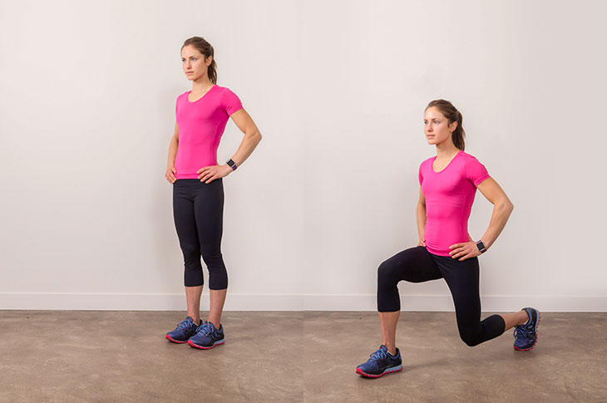Stand up with your chest up and your eyes ahead. Then step 2 or 3 feet forward with your right foot.
2. Allow both knees to bend until your front knee is at about a 90-degree angle, with your knee behind your toes and your back knee a few inches above the floor.
3. Ensure that you step your right foot far enough forward so that the middle of your front knee is directly above your ankle during the downward motion. It is also essential that you lower straight down with your back straight.
4. Press into your right foot, and press back to start. Repeat your actions but stepping forward with your left foot this time—alternate legs for 8 to 12 reps per side.

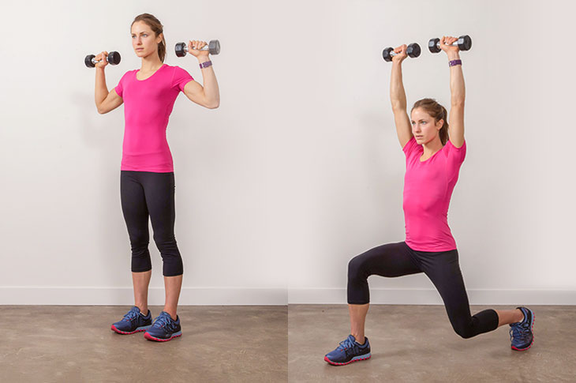**Lunge With Dumbbell Press**

1. Stand with two lightweight dumbbells in both hands. Each dumbbell can about two to five pounds each.
2. Holding the dumbbells at chest height with your arms facing forward, step forward into a lung.
3. As you lower your body toward the floor, lift the dumbbells overhead and keep your elbows slightly bent, and your arms just in front of your ears.
4. Step back to start and lower the dumbbells, repeating on the other side. Alternate for 10 to 20 total reps.

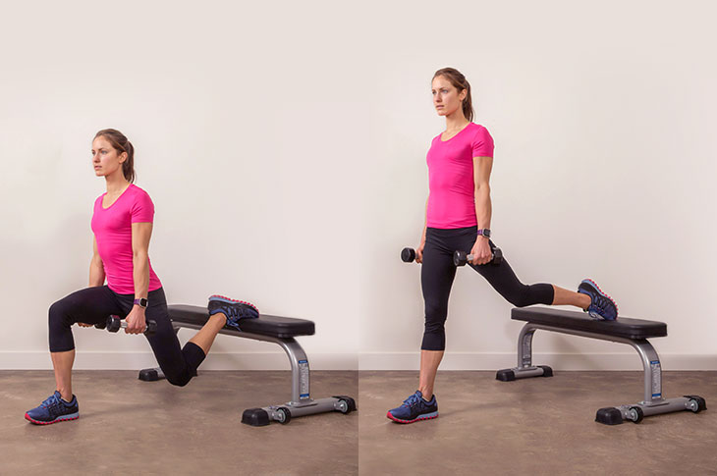**Balance Lunge**

As its name suggests, this move helps fine-tune your balance and provides an extra challenge to glutes and thighs. Balance Lunges also work your core, which fires up to help stabilize your body during the entire exercise.

1. Place a bench or sturdy chair and stand about 2 or 3 feet away from it.
2. Place the top of your left foot on the bench and slowly lower your body into a classic lunge pose.
3. Ensure that you keep your right knee behind your right toes. Then press back up to start. You can perform 8 to 12 reps before switching sides.

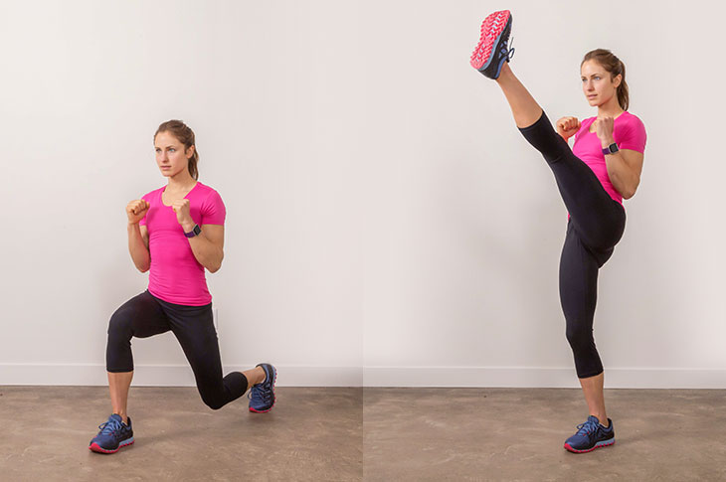**Lunge With Kick**

This variation of lunge gives your body an extra balance and core challenge. It is entertaining. It creates an added strength boost as it forces you to land softly and slowly on your back leg.

1. Stand straight with your hands on your hips or clasped in front of your chest, or holding a light pair of dumbbells. Then step forward with your right foot into a lunge.
2. Press your body up toward your start position and kick up with your left leg before stepping your left foot back behind you into a lunge. Perform eight to12 reps before switching sides.

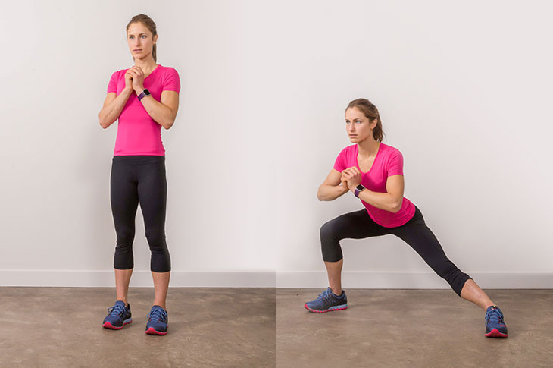**Side Lunge**

Making side lunges involves moving your body laterally, working on the sides of your thighs and glutes as well as strengthening your muscles in new ways.

*How to make side lunges*

1. Stand with your feet hip-distance apart, and your hands clasped at your chest or on your hips. Ensure that your hips and knees are also slightly bent.
2. Keep your chest and head up. Step about three feet to the side with your right foot and with your toes facing forward, and maintaining your slightly lower stance.
3. Bend your right knee and sink your hips low toward the floor. Press back off your right foot and return to start.

**Simple Lunge Plan To Follow**

As a beginner, you can start with the first three lunge exercises. Integrate the three poses in your workout routine per week.

Ensure to hold each lunge pose for 10 to 20 seconds. Repeat the entire series three times in total.

When you become well versed with the first three lunge poses, you can advance to incorporating the final two exercises into your workout routine, holding each one in a total of 30-60 seconds.

Having gained full control of all, integrate all the five poses into your workout routine per day.

Start with a 10- to 30-second hold, and increase your time from there. Make two minutes your maximum time limit.

Chapter 5

# SQUATS

Now that you have become acquainted with upper body and full-body exercises, you can now be introduced to one of the most popular lower-body activities, the squat.

The squat is a fundamental exercise in any fitness routine. You can learn to do squats with weights or without weights’ at home. Squats, also known as deep knee bends, look reasonably simple to do, alas looks are deceiving. You may remember jumping frog when you were a toddler; well, they are similar in some ways in that jumping frog also helps to strengthen your glutes and some of your lower- body muscles.

There is no correct way to stand when you want to begin your squat, but make sure that your feet feel firm on the floor. If you feel like you might topple over before you start, you are not getting it right.

The point is that there is no exact formula to begin the squat, just make sure that you are well balanced. You may position your feet wide apart, or they may be more narrow and closer together—the more full the distance between your feet, the wider the stance you have assumed.

Your glutes and hamstrings are worked when you assume this stance. The narrower your posture, the more your quads are worked. When your feet are parallel to each other, less pressure is placed on your glutes and hamstring muscles, whereas when you turn them outwards a little bit, more emphasis is placed on said muscles. Your head should look forward, while your back shouldn’t bend forwards as it might naturally want to, make sure to hold your back upright.

Earlier, I said squats are a fundamental exercise, which means that it can be performed at the gym or home, at the gym, you may use more fancy equipment, but at home, you can improvise with heavy objects for weights instead of dumbbells, you may use furniture as bars instead as well.

As necessary as the squat is an exercise, there are immense benefits to be gained from consistently. The squat falls into the class of compound exercise earlier discussed. Every time you do squat repetitions, you are burning lots of calories, and long after you have finished the reps, you are still burning calories.

Squats are also an excellent exercise to strengthen your heart, thereby promoting your cardiovascular health. If you squat about 15 times at a stretch, it will spike your heart and breathing rates, which serve as good training for your heart.

You can also do several reps with short break intervals to achieve a high-intensity interval cardio work out. Your entire body is also strengthened by consistently doing squats in your fitness regimen. If you do squats with weights or improvised alternatives, you will start to notice that you have become considerably more robust.

Some of the muscles worked when you do squats are your quadriceps, your hamstrings, your calves, your lower back, your shoulders, and your glutes. You can assume from this that it is a total body weight routine designed to strengthen your whole body.

Squats promote the increase of your muscle mass, which is no surprise since all the muscles of your body are working in this exercise. When this happens, it means that other exercises would be more straightforward for you to perform better.

Many cardio workouts involve the use of your lower-body muscles. By having a healthy body, you can do other exercises better. If you are looking to lose weight, squats will help you in that pursuit as well. To achieve this, you may want to use loads more when you perform those squats. That way, you burn more calories and enter a calorie deficit, which is the primary way to lose fat and, therefore, weight. You will also gain muscle, so some of the weight lost will come back as healthy and toned muscles.

**Different Levels of Squats**

There is the traditional squat, and there are some other advanced, more difficult squats that you can learn to do as time goes on.

Remember that you can always improvise in your house, or you can purchase some weights like dumbbells, which are small enough to use at home. Since we are dealing with home fitness, the easiest one to do at home is the traditional squat.

1. **Easy (traditional)**

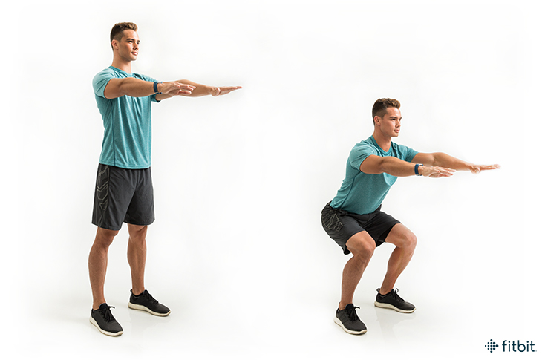

1. Place your feet firmly, and slightly angled outwards on the ground, they should be approximately shoulder-width apart
2. Bend your knees. Just imagine that you are about to sit at an interview. Keep your heels firmly on the ground, and make sure that your back is upright
3. Inhale as you lower your body slowly and steadily as you extend your arms forward for balance.
4. Exhale as you rise, and keep your face forward to maintain proper form.

Repeat the process about ten times if you are just starting.

1. **Advanced (with dumbbells)**

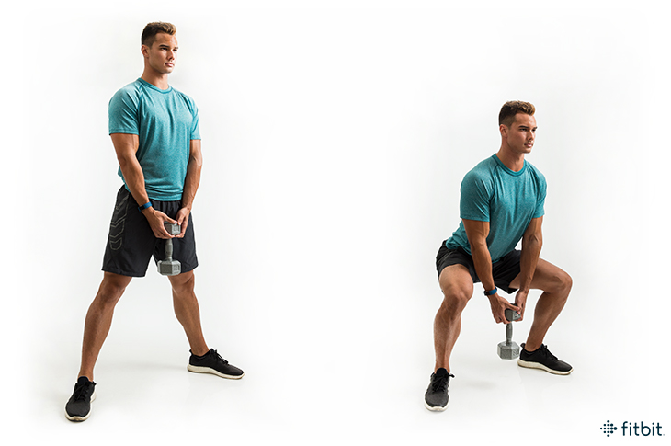

You can do a more advanced version by doing deep knee bends.

1. Stand with your feet about 15 inches apart.
2. Place your hands on your hips
3. Inhale as you squat down till your thighs are parallel to the floor
4. Exhale as you slowly rise while your body is upright

You can do interval repetitions for more benefits.

**Simple Squat plan follow**

Do not start by bending your knees first, though it is natural

As you descend, nudge your knees slightly outward and not inward, your kneecaps should point to the same direction as your toes.

Squatting three sets of 12-15 reps several times a week will have you on your way to more strength and toner lower body muscles

3×12 sits every morning in your routine.

Chapter 6

# ABS TRAINING

Your home is one of the best places for your abs training. After all, we have heard of six-pack abs being mostly made in the kitchen.

The goal of most of our fitness activities at home is to build strong abs as which are an integral part of a rock-solid core. A rock-solid core is a foundation upon which so many of our other beneficial fitness goals are achieved from proper posture and prevention of lower back pain as well as easy mobility and athletic strength.

The recipe for strong six-pack abs is not that complicated. It involves marking out a consistent abs workout and eating a nutrient-rich diet. Unfortunately, there is an inexhaustible volume of exercises and tricks. However, we will be discussing some of the abs training exercises that are convenient at home for both men and women.

We must understand that abs training is not only designed for the six-pack look! It plays a crucial role in improving posture and stability, reducing lower back pain as well as assisting with producing a firmer waistline.

***Reduces lower backpack****.* Abs training helps to reduce lower back pain, which is a problem affecting many people from all backgrounds. Most people have weak abdominal muscles because of the rigidity in their joints, which occurs because of a lack of exercise. Abs exercises target these back muscles and the spine, thereby making them more flexible and less rigid, thus reducing lower back pain.

Improves posture and stability. Abs workouts focus on the abdominal muscles, which are essential for posture and stability. It strengthens the muscles around the spine and enhances harmony between tissues in the body. It, in turn, improve posture and balance as the body’s weight is correctly distributed.

***Produces a firmer waistline****.* Abs training help to reduce excess body fat, usually associated with diabetes or obesity. It does this by increasing the muscle mass in the abdominal region as well as body metabolism. All of which helps to produce a leaner body with a firmer waist.

**Different Levels of Abs Training**

There are different levels of abs exercises. This directly translates to their level of difficulty. To ensure you quickly adapt to abs training, I am going to start from the easiest of the lot to the hardest. Yes, one will do. However, for abs training, you need to try out as many variations you can possibly try out. This will ultimately build every part of your abs.

**Side-to-side**

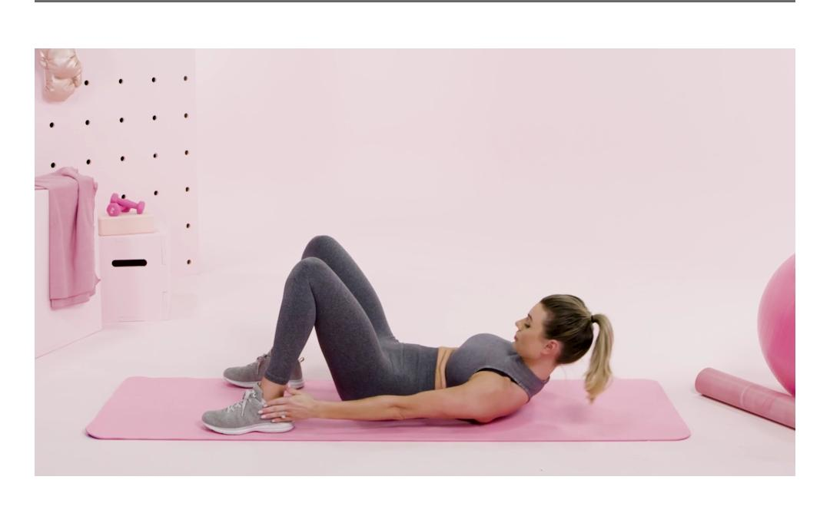The side-to-side abs training work out routine is useful for obliques.

Lie on your back with your hands by your sides, your head, and shoulder blades a bit forward and off the ground, and finally, your knees bent.

Without putting your head and shoulder blades down back, reach for your left ankle with your left hand.

Do the same with your right hand and your right ankle.

Keep up with the sequence until you are ultimately worn out.

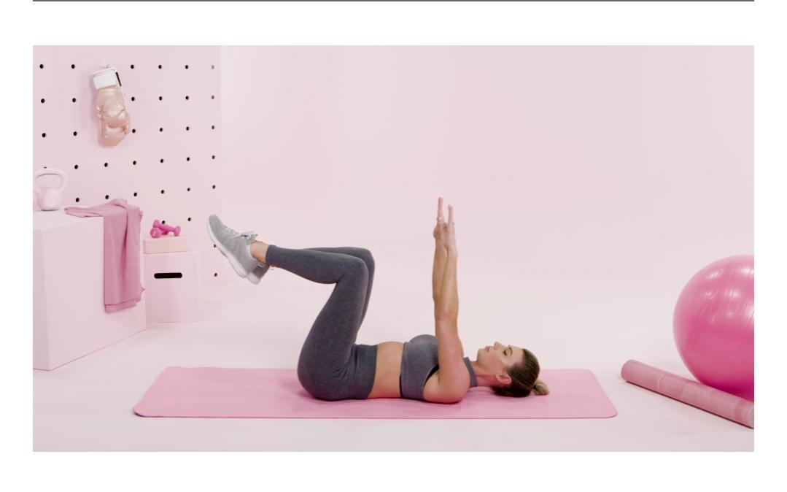**Dead bug**

The dead bug is an excellent choice for beginners to build their abs at home. It goes effortlessly on your neck and back, which is not the case for many other abs exercises. Here is how it is done.

Lie on your back with your arms extended to the ceiling. Then raise your legs and bend your knees until they’re at 90°.

Now slowly but with full control, lower your left arm towards the ground and extend your right leg at the same time, so both limbs end up parallel to the ground.

Reverse the movements, then repeat with the other arm and leg. You can spend about three seconds, lowering and raising and do three sets of five reps on each side.

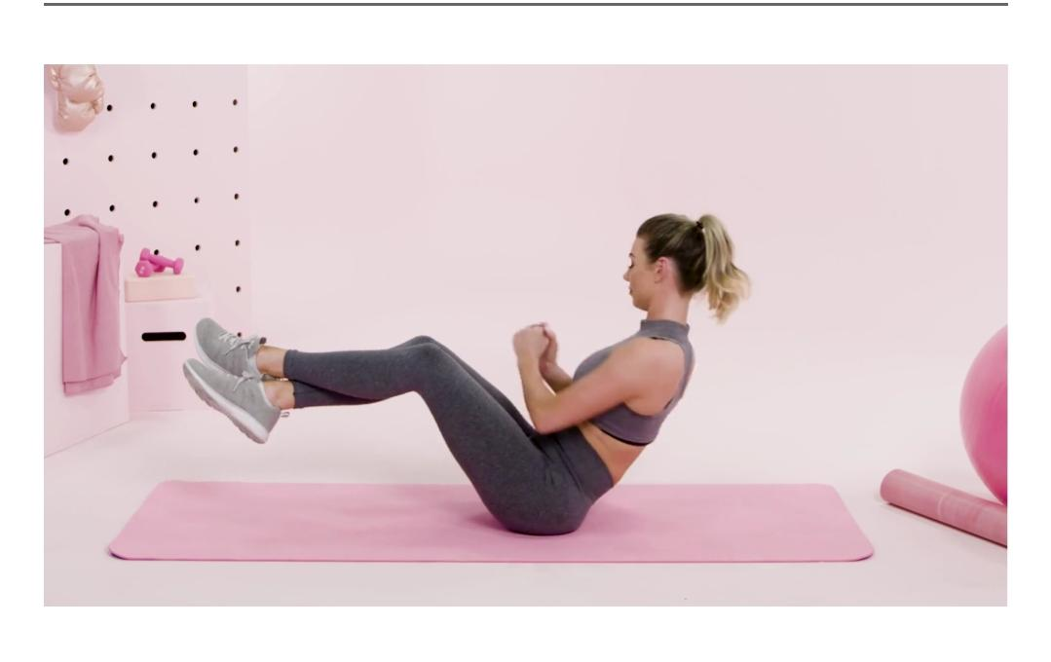**Grounded Russian twist**

This particular exercise has different variations, but it is more worthy of mastering the basic version of this exercise because it hits your obliques, which is often neglected.

Sit on the floor with your knees bent and heels resting on the ground. Lean back so that your torso is at 45°.

Keep your chest up so that you do not hunch your back. Interlock your fingers and extend your arms in front of you.

Turn your torso to the left side while bringing your hands to touch the ground on that side.

Rotate back to center and then carry on to turn to the right side. Once you have mastered the basic movement, you can make it more challenging by adding variety like raising your heels off the floor.

**Alternative toe reach**

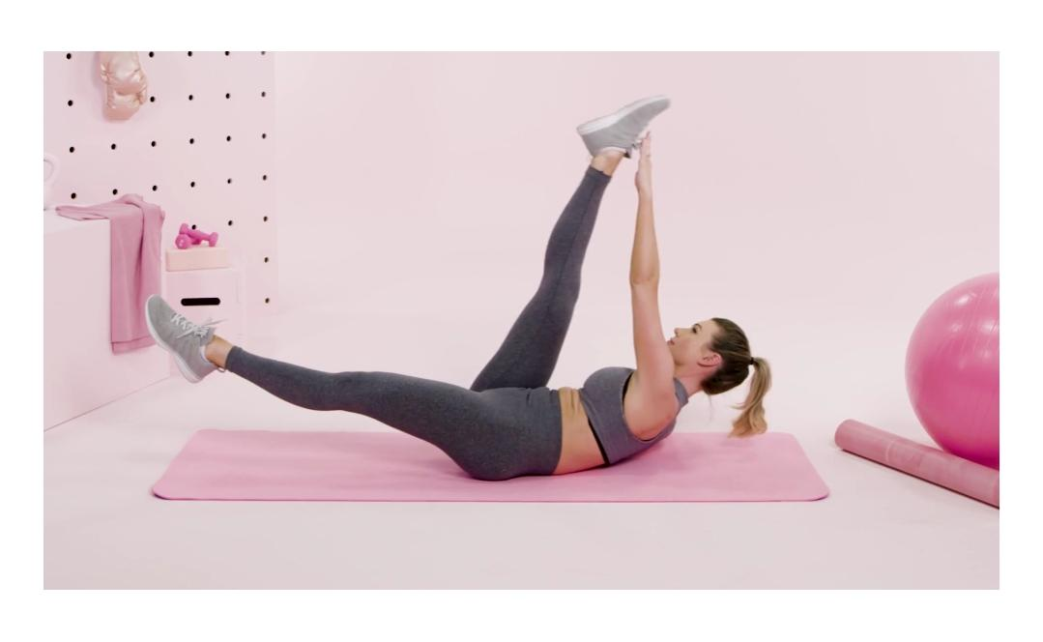This level of abs training is excellent for transverse and oblique abs.

Lie on your back with your legs extended in the air

Place your outstretched arms on the floor by your sides

While still in this position, raise your right hand to meet your left toe, which will also be outstretched.

Repeat these sequence with your left hand and right toe.

Keep this work out up until you feel the muscles at your abdomen tightening. Keep going.

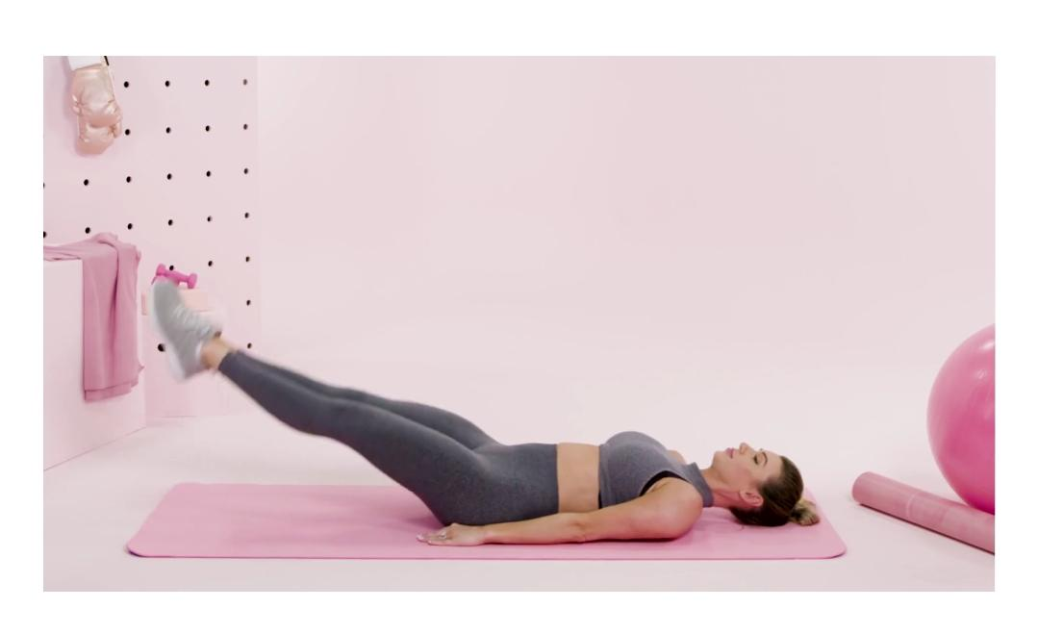**Leg raise**

This is a little complex ab training exercise for intermediates at home. Leg raising involves engaging your lower abs and your core by flattening your lower back on the floor. Now here is how it is done!

Lie down flat on your back while keeping your legs as straight as possible. Now raise your legs until they are as vertical or as close as you can get. Lower them and repeat.

To make it easy for yourself. You can tuck your knees in and start with your legs raised. Then you can slowly lower them towards the floor. Having mastered this, you can begin to keep your legs straight when you are returning to the top position. In case you feel a niggle in your lower back, then place your hands under your buttocks to help keep your lower back flat.

**Simple Abs Workout Plan To Follow**

Having discussed these abs exercises and the pro tips that you can use to ensure that you execute each one correctly. This is a simple plan you can choose to follow.

Incorporate these five abs exercise into your daily fitness routine.

Try three sets of each movement. Spend about 20seconds on each. Rest for 30 seconds between each set.

Chapter 7

# BRIDGE EXERCISE

The Bridge exercise, which is also known as Glute bridges or Hip Raises, is an extremely useful albeit challenging exercise. The muscles worked when you perform reps of glute bridge are the muscles of your calves, your hamstrings, and your glutes.

These muscles make up your lower body muscles, as you must have understood from the previous exercise routines I discussed. Those muscles generate power in your lower body, and they are compelling. Because they are so powerful, you will need to expend a lot of energy to operate the muscles. This implies that when you work these muscles when exercising, you burn a whole lot of calories. You may like the idea of this if your aim for fitness is weight loss or strength building.

Just like the other exercises in this book, this exercise applies to all fitness levels-beginners, intermediate, and advanced levels.

If you decide to combine this exercise with the other exercises here, while consistently performing the reps, you will reap several benefits. Your posterior chain, which comprises the muscles of your calves, hamstrings, and glutes should be an aim for strength building. This is because it plays a critical role in stabilizing your core and giving power to your lower back.

When you perform this exercise consistently with proper form, the glute bridge will drastically improve the vitality of muscles around your spinal column (*your erector spinae*). This has an effect on the development of a good body posture. If you master the process of performing a glute bridge, your glutes will naturally gain more definition, and therefore leaves you with a firm and more toned backside. If you work at a sedentary job, or your occupation involves you having to sit for long hours, then this is an excellent exercise for you.

The glute bridge is also a great way to stretch your pectoral muscles and your anterior deltoids ( a part of your shoulders).  This exercise also aids the firming of your abdominals and therefore gives you a more defined waistline and a flatter tummy. This thinking that this move also tones the muscles that define a six-pack.

When the muscles of your lower body are strengthened, it aids your performance in more exercises. This is because strong muscles are less prone to injury. The muscles in your knees and ankles become fortified and more up to the task of various vigorous exercises.

This move is a low- impact move that requires zero equipment and minimal space. You may use a mat to prevent injury as a result of friction or the lack thereof. If you have dumbbells, you may also use it in performing the exercise to work your upper-body muscles as well.

**Different levels of Bridge Exercise**

To reap the most benefits of this exercise, I will explain the different variations or standards that you can perform. Judge by your level of difficulty prowess which ones you can try out, but these exercises are laid out from the beginners level to the more advanced learner's level.

* **Beginners Level**

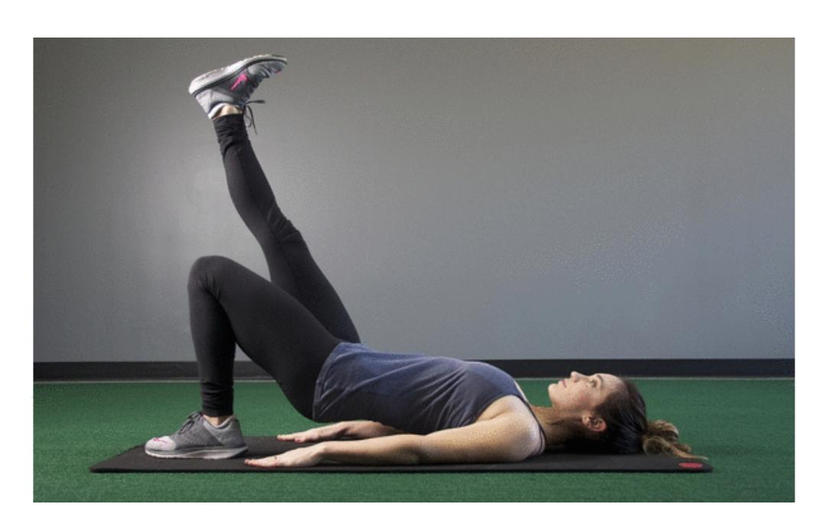**Regular Glute Bridge**

1. Lie on your back with your body relaxed
2. Keep your hands at your sides
3. Bend your knees hip-distance apart
4. Keep your feet flat on mat stacked under the knees.
5. Engage your core muscles
6. Squeeze your glutes firmly
7. Push your low back into the ground
8. Raise your hips to form a bridge
9. Squeeze your core and pull your belly button back toward your spine
10. Hold your body in that position for about 10 to 20 seconds
11. Slowly and steadily return to the mat with controlled movements
12. Perform at least ten reps

* **Advanced Level**

**Single- leg bridge**

1. Begin at the starting point for a regular deck.
2. Raise your pelvis
3. Raise your left leg
4. Hold that position for some seconds
5. Slowly lower your leg till it is almost touching the floor
6. Lift the pin once again and hold for about 10 seconds
7. Lower yourself back to the floor
8. Repeat the above steps, but this time, switch to the right leg.
9. Aim for ten reps on each side.

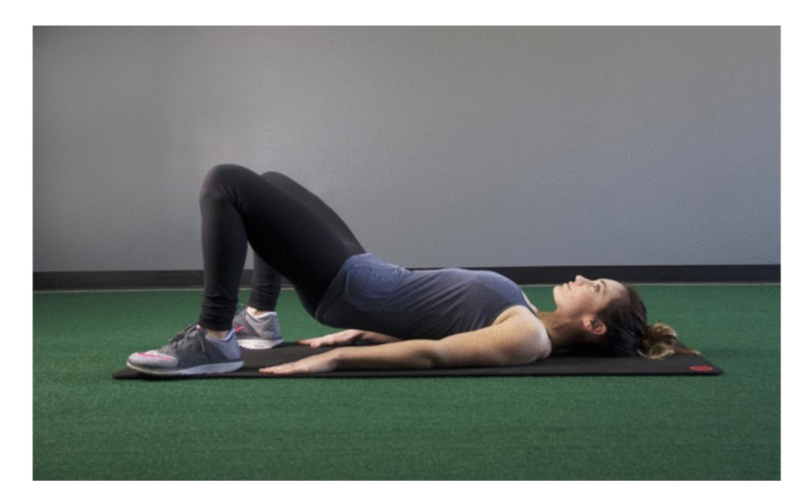**Press through the toes Bridge**

1. Start flat on your back with your legs bent at a 90-degree angle and feet placed flat on the ground.
2. Raise your heels, drive your weight down through your toes, and elevate your hips.
3. To make sure you are targeting the posterior portion of your thighs, draw your toes off of the ground as you drive up.
4. With a slow and steady movement, let your hips sink back down toward the ground. This completes one repetition.
5. Perform three sets of 15 repetitions or three rounds of a 30-second hold.

**Press through the heels Bridge**

1. 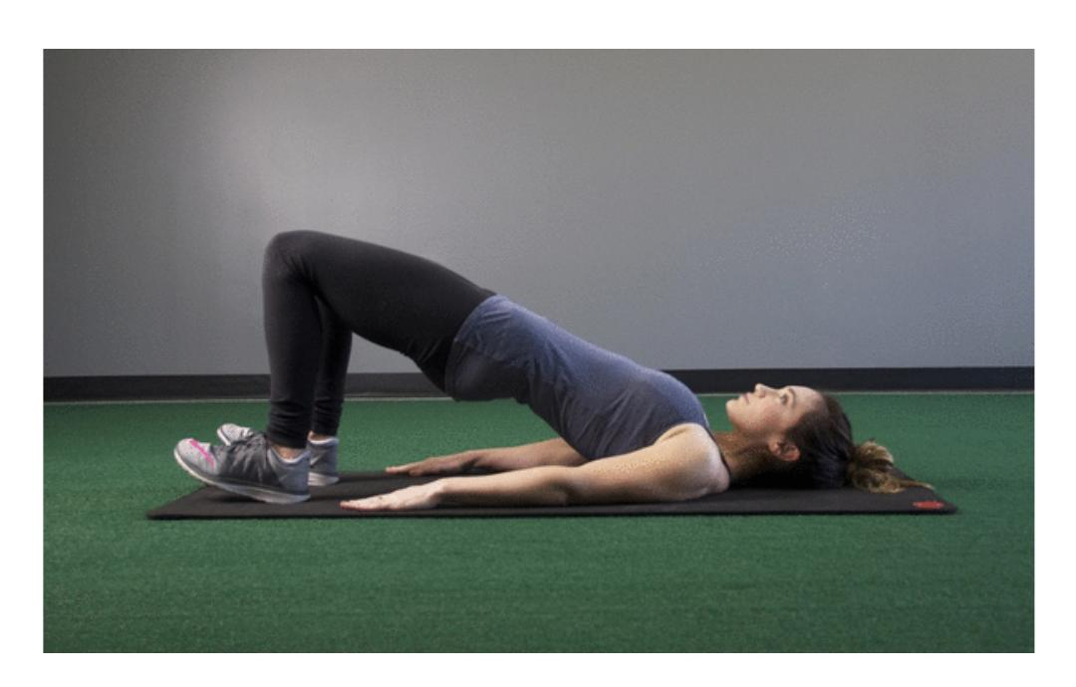Start flat on your back with your legs bent at a 90-degree angle and feet placed flat on the ground.
2. Drive your weight down through your heels and elevate your hips.
3. You should feel this variation fatiguing the back of your legs and glutes.
4. To make sure you are targeting the posterior portion of your thighs, bring your toes off of the ground as you drive up.
5. In a controlled motion, let your hips sink back down toward the ground. This completes one repetition.
6. Perform three sets of 15 repetitions or three rounds of a 30-second hold.

**Simple Workout plan to follow for Bridge Exercise**

Add Bridge Exercises to your lower body workout at least twice a week. Target 4 sets of 10–15 reps of the bench dip.

Start at the beginners level

As you consistently perform the beginners' level, you can then proceed to complete the more advanced variations.

Do not perform Bridge exercises if you are in the final stages of pregnancy, or recently delivered. Don’t do this exercise if you are healing from surgery or an injury involving your back, abdomen or pelvis, hips joints, knees, or ankles.

# START WORKOUT NOW

If you have read all the chapters, maybe you have even started working out in your home, then congratulations! You are well on your way to becoming more fit.

Some key things you should remember is the importance of consistent routine. If you slack off on some days, it will take longer for your muscles to develop, and you will continue to feel significant pain while performing basic exercises.

But if you are doing the exercises regularly, your muscles grow stronger and become more used to the activities, and therefore, you will feel less pain when you do them. Sweat it out by doing sets and repetitions. You can do three sets of up to ten repetitions of each exercise.

If you do a sum of thirty sets in less than an hour. How fast you progress is a factor of the kind of goals you have set for yourself. If you simply want to get in shape, you can repeat the exercises in this book for six months, and you will have muscles and shapes to show for it.

Do not overdo it. Trust your body to tell you when you are doing too much. Excruciating pain is usually an excellent signal to say to you when to stop.

Also, remember to stretch as a warm-up before you start any exercise. Stretching elongates your muscles, and it helps you to work out better. Overall, it is your whole body that matters, and doing all this exercise won't only keep you fit but healthy towards a long-lasting life free on common health complications.

*NOW, LET’S START WORKOUT!*